The Conservative Synagogue of Fifth Avenue
looks forward to welcoming you at
High Holiday Services 2026

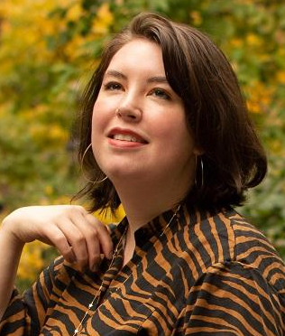
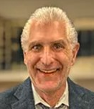

Hazzan Sarah King
Rabbi Mitchell Blank
Rabbi Mitchell Blank is a lifelong member of the Conservative Movement. He was ordained by The Academy for Jewish Religion and has previously served as spiritual leader of Temple Beth El of Manhattan Beach New York. Rabbi Blank earned a B.A. from Boston University and a J.D. from Fordham University School of Law. Before ascending to the Rabbinate, he had a successful career as a serial entrepreneur. Rabbi Blank is married to his childhood sweetheart Rose and they are both the proud parents of their daughters Elana and Paula.

A vital and central part of our synagogue life, Sarah King has served the CSFA community as Hazzan since 2014, when she was a student at Stern College for Women of Yeshiva University. Sarah hails from Baltimore, Maryland, where she attended the Bais Yaakov School. Growing up at Beth El Congregation, where her father is the Hazzan, she served as Bnei Mitzvah tutor, Torah reader, and led the interactive family High Holiday services. In addition to her synagogue career, Sarah is also a harpist and singer, having been involved in past performances with the High Desert Opera Company in Grand Junction Colorado, including The Mikado, The Barber of Seville, and The Elixer of Love. A graduate of the Cardozo Law School, Sarah made aliyah in the winter of 2022 and currently resides in Jerusalem. She is making a special trip back to the United States for the High Holidays to celebrate with her CSFA community.

The Conservative Synagogue of Fifth Avenue
holds its High Holiday Services at
Center for Jewish History - 15 West 16 Street New York, NY 10011
(unless otherwise indicated)
Selichot Saturday, September 5, 2026
(With Rabbi Blank at 11 East 11 Street)
Erev Rosh Hashanah Friday evening, September 11, 2026
Rosh Hashanah Saturday, September 12 and
Sunday, September 13, 2026
Yom Kippur (Kol Nidre) Sunday, September 20, 2026
Yom Kippur Monday, September 21, 2026

For membership information or High Holiday tickets, please contact the office at the
Conservative Synagogue of Fifth Avenue 11 East 11 Street New York, NY 10003
Telephone: 212-929-6954, email: csfa11e11@aol.com, or visit our website - www.csfany.org
Best Wishes for a Sweet and Healthy New Year.
לשנה טובה ומתוקה
Hazzan King’s participation in High Holiday Services is made possible by the
Herbert and Hon. Rose Rubin Music Fund at CSFA

H

